1.Purpose of this individual reflection paper:
The purpose of this report is using the statistics knowledge learnt from the GESB1013 to do the data analysis associated by computer science.

2.Background and Objective
This report analyzes long-term fertilizer use (ag_con_fert_pt_zs, kg/ha, meaning Agricultural Use of Fertilizers (kg per hectare of arable land)) from 1980 to 2020 across nine countries: Australia(aus), Brazil(bra), China(chn), Germany(deu), the United Kingdom(gbr), India(ind), Japan(jpn), the United States(usa), and South Africa(zaf).
The research aims to answer:
1. How has fertilizer use changed over time in different countries?
2. Do countries differ significantly in their fertilizer use levels?
3. Is fertilizer use positively or negatively associated with time?
4. Which countries show stable patterns and which show high volatility?
To address these questions, this report apply statistics knowledge such as descriptive statistics, trend visualization, correlation analysis, linear regression, and ANOVA. Using python and several tool packages to calculate the results and draw the graph, which are shown below:
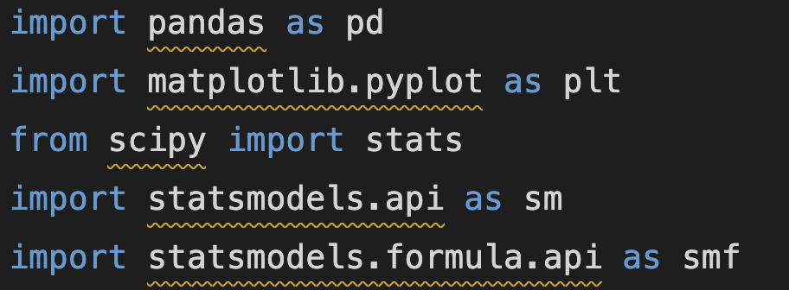

3.Data and Methods
(1) Data Structure
The dataset which is filtered_data.csv contains 41(369 in total) yearly observations (1980–2020) for each country.
The reason why choosing these nine countries: The chosen countries consist of three high-income, three medium-income and three low-income to make sure the result without any ‘bias’.
Key variables:
• geo: country code
• time: year
• ag_con_fert_pt_zs: fertilizer consumption (kg per hectare)
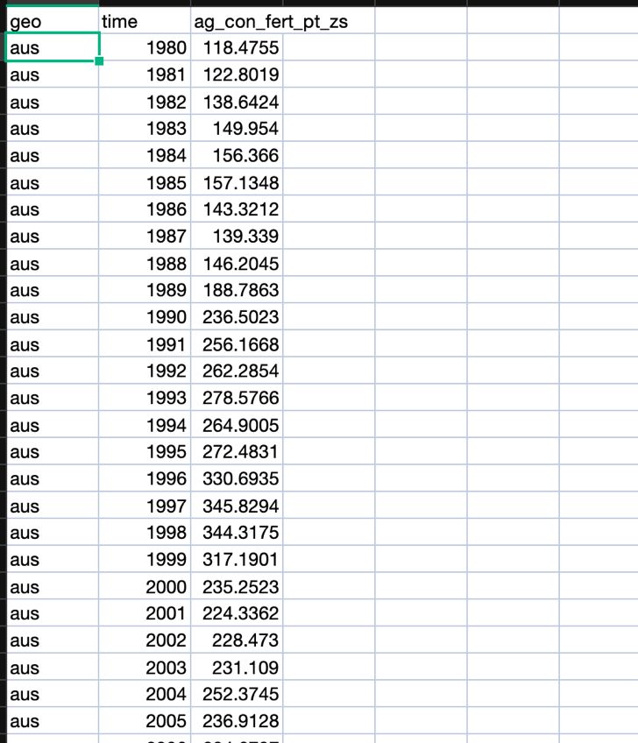
The dataset is supported by https://www.gapminder.org/data/ run by Gapminder Foundation, a Swedish non-profit organization.
4.Descriptive statistics
After the calculating by statistics.py,


the resulting table is shown below:
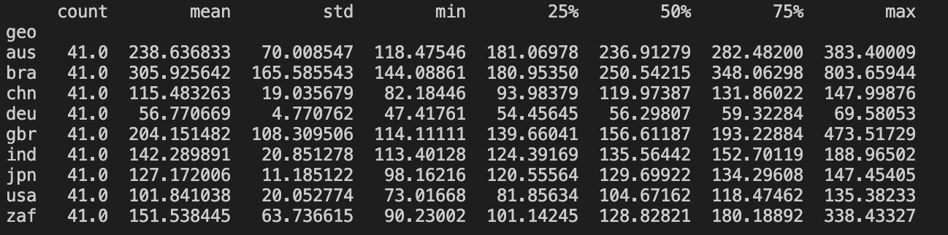
The table clearly shows that between 1980 and 2020, the use of fertilizer saw a huge difference across countries. Brazil and Australia ranked high levels, while countries like Germany and the United States saw lower and more stable trend on usage. Brazil, the United Kingdom, and South Africa saw a fluctuation on the use of fertilizer probably caused by the climate change, national government decision and so on.
The trend graph is also plotted by
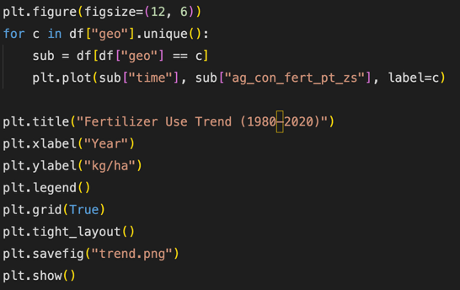, the trending image is shown below：
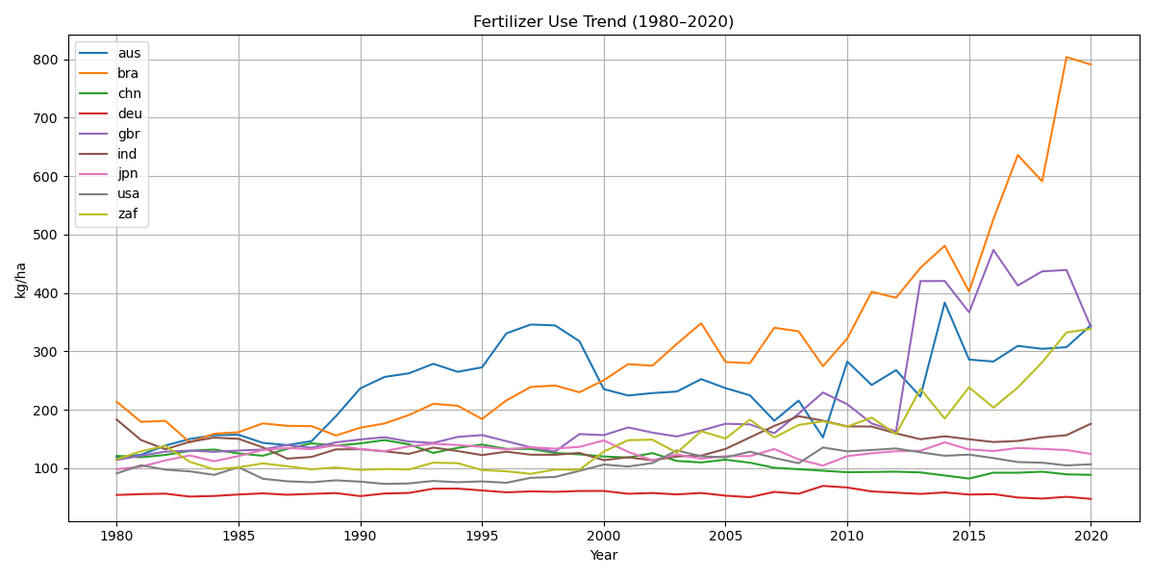
The figure above illustrates the fertilizer use trends (kg/ha) from 1980 to 2020 across nine selected countries: Australia, Brazil, China, Germany, the United Kingdom, India, Japan, the United States, and South Africa.
Brazil has a tremendous increasing on the use of fertilizer and gbr, aus, zaf apparently has the same trend but with less increasing ratio. The remaining 5 countries keep the level of using fertilizer stable.

5.Correlation Analysis
Next comes to the Correlation Analysis, the program output every countries’ r and their corresponding p-value.

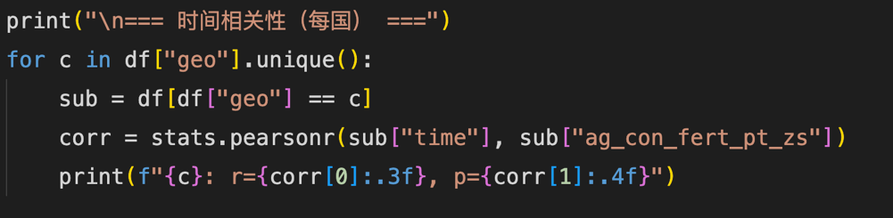
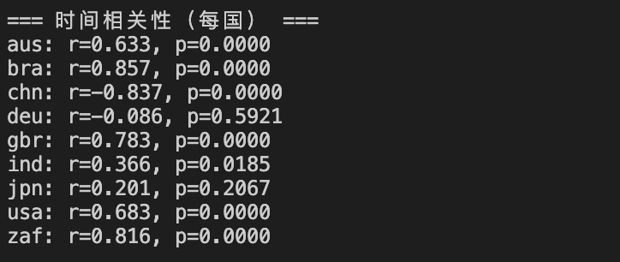
Based on the correlation table, the change of the trend of using fertilizer in different countries has significant differences as time goes by. Among them, Brazil, South Africa and Indian shows a dramatical Positive correlation, which indicate that in the past 40 years, the consumption of the fertilizer in these countries grew rapidly. Parallelly, Australian and China saw a medium positive correlation. Conversely, Germany, Japan and United states of American presented a less correlation, which means the stability of the use of fertilizer.
6.OLS Regression Analysis:
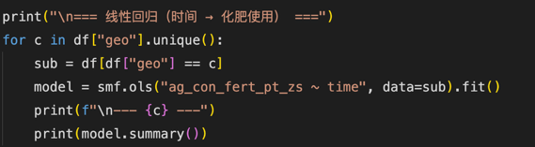
The tables below show the OLS Regression of each countries where the detail of the Regression formula is shown below.
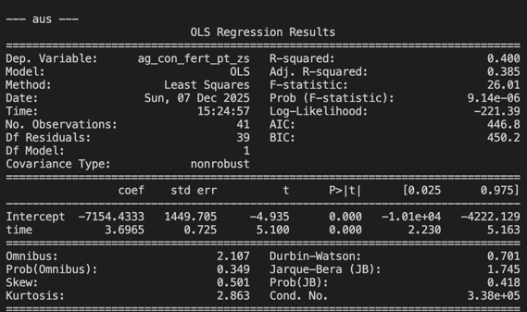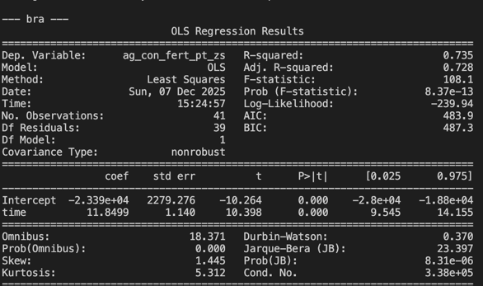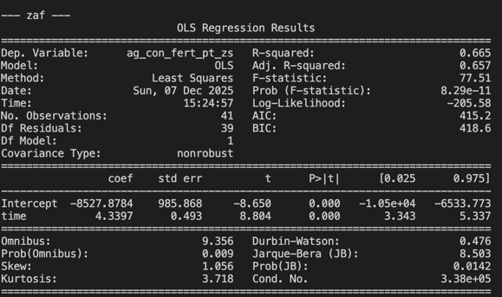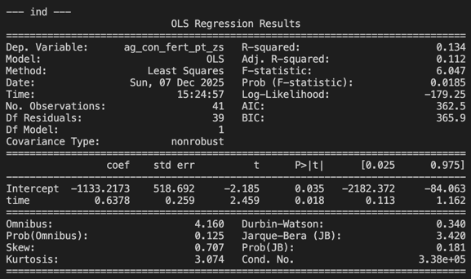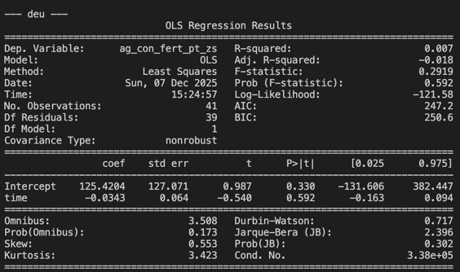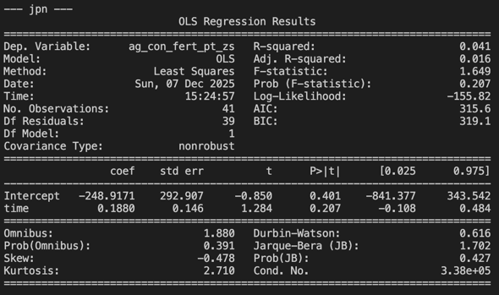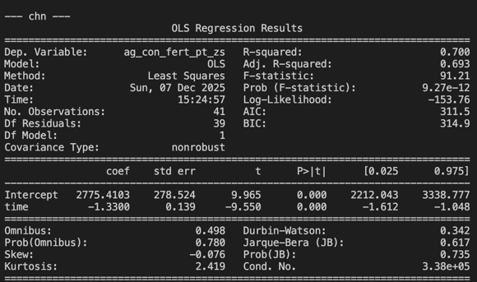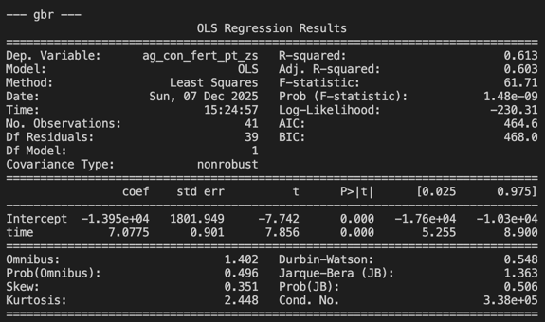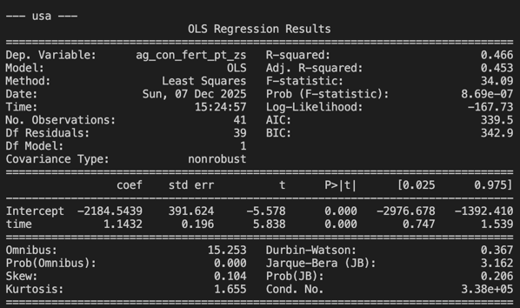
Conclusion based on the OLS Regression Analysis:
First, From the trending graph’s perspective, it is very obvious that there is a huge difference among these nine countries in terms of the use of the use of fertilizer. Brazil, South Africa, United Kingdom and Australia saw an apparent up ward trend. Germany, Japan and USA keep using filters steadily. On the other hand, China and India presenting phased changes.
The OLS Regression Analysis further quantified the time impact on the use of fertilizer. Brazil (β₁≈11.85, p<.001) and South Africa(β₁≈4.34, p<.001) shows a strong Time effect, whose consumption of fertilizer increased rapidly in the past 40 years. This phenomenon illustrates that these low-income countries are situating at the age of expanding their development of agriculture and productive forces. The increasing results from developed countries like Australia and United kingdom on the other side shows that Modern high-tech agricultural production techniques also require the support of chemical fertilizers to be implemented.
Noticeably, China’s β₁(–1.33，p<.00) is a negative number, which means that since 1980, the overall use of fertilizer decreased on the contrary. This outcome is mainly caused by China's green agriculture policies in recent years, such as optimizing fertilizer structure and improving utilization rates, are highly consistent. This is a very meaningful observation in this report.
Compared to the above countries, considering Germany, Japan and USA, their OLS Regression are not dramatic, which present a Long-term stable state. That means these countries’ with high-income agricultural development is relatively mature, with high fertilizer utilization rates, which also reflects the relative stability of its agricultural technology.
Another distinguished point is that though Indian shows a dramatic positive correlation. But the R-squared merely equals to 0.134, indicating that the amount of fertilizer use can be easily impacted by the weather change, biological factors and so on followed by fluctuation.
In summary, these nine countries can be divided into four groups: developing agricultural powers led by Brazil; developed agricultural countries led by Germany, Japan, and the United States; countries like China that are transitioning to developed agriculture; and finally, countries like India that are heavily influenced by external conditions.

7.ANOVA Analysis:
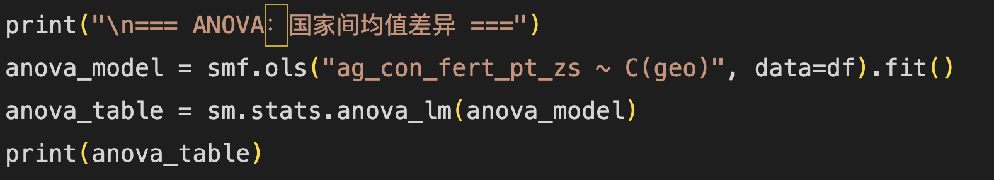
The result of ANOVA Analysis among countries is shown below:

To examine whether there are significant differences in fertilizer use among different countries, a one-way ANOVA was conducted on these nine countries. The results show that the country factor has a highly significant impact on the mean fertilizer use. F(8, 360) = 43.75, p < 1×10⁻⁴⁸. Such extreme significance demonstrates that the vast differences in agricultural fertilization levels between different countries are almost impossible to be caused by random fluctuations.
In terms of the distribution of squares, the squares of houses (1.92×10⁶) between groups and within groups (1.98×10⁶) are roughly equal, which reflects the systemic differences in agricultural development, arable land structure, and policy systems across countries.

Conclusion:
This statistic report collect the use of fertilizer data in different countries, analyzing the data based on descriptive statistic, regression analysis, ANOVA analysis, which clearly shows their different features and significant differences and structural characteristics in fertilizer use across countries and over time.
The calculation result is achieved by python and its tool package. The source code is saved as data.py (csv data processing) and statistics.py(calculating). The data is stored as filtered_data.csv. You can check the code and data and run them on

Individual reflection:
Since my major is computer science, I want to finish this project associated by coding and technology stack I have learnt before. The basement of this project is originated from this course. With the help of some descriptive statistic, regression analysis and ANOVA analysis I have learnt from this course (GESB1013), I can finish this data analyzing. I think that is the joy of interdisciplinary application!

